Operating Systems Design for Embedded Environments

**Practice 2 0.0 OS Scheduler**

|  |  |
| --- | --- |
| **Project:** | **OS Scheduler** |
| **Team:** | **Team 4** |
| **Date:** | **01/03/2014** |
| **Comments:** | **This is just an initial draft, can be changed if needed.** |

**Table of Contents**

Operating Systems Design for Embedded Environments 1

1. SW Conceptual design 3

2 Function Description and Dynamic Behavior 3

*2.1* Function *void SchM_Init (SchM_TaskConfigType *SchM_Config)* 3

*2.2* Function *void SchM_Deinit (void)* 3

*2.3* Function *void SchM_Start (void)* 3

*2.4* Function *void SchM_OsTick (void)* 4

*2.5* Function *void SchM_Background(void )* 4

*2.6* Scheduler task callback functions 4

# SW Conceptual design

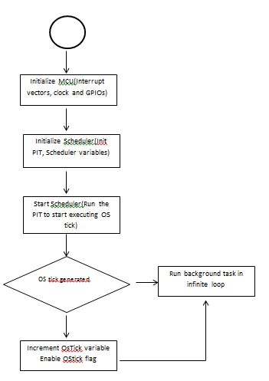

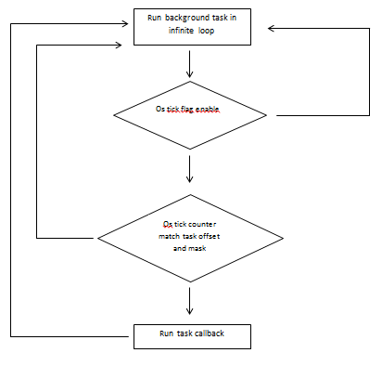

# Function Description and Dynamic Behavior

## Function void SchM_Init (SchM_TaskConfigType *SchM_Config)

|  |  |  |
| --- | --- | --- |
| **Description** | *Void SchM_Init(SchM_TaskConfigType *SchM_Config);* | |
| **Return Value** | *None* | |
| **Precondition** | *None* | |
| **Parameters** | *SchM_Config* | *Pointer to the module’s configuration structure* |
| **Error Conditions** |  | |

**Dynamic Behavior**

SchM_Init function shall allocate and initialize the resources to be used by the Scheduler Module.

## Function void SchM_Deinit (void)

|  |  |
| --- | --- |
| **Description** | *Void SchM_Deinit(void);* |
| **Return Value** | *None* |
| **Precondition** | *None* |
| **Post condition** | *None* |
| **Error Conditions** |  |

**Dynamic Behavior**

SchM_Deinit function shall finalize and free the resources used by the Scheduler Module.

## Function void SchM_Start (void)

|  |  |
| --- | --- |
| **Description** | *Void SchM_Start(void);* |
| **Return Value** | *None* |
| **Precondition** | *None* |
| **Post condition** | *None* |
| **Error Conditions** |  |

**Dynamic Behavior**

SchM_Start API shall start the scheduler.

## Function void SchM_OsTick (void)

|  |  |
| --- | --- |
| **Description** | *Void SchM_OsTick(void);* |
| **Return Value** | *None* |
| **Precondition** | *None* |
| **Post condition** | *None* |
| **Error Conditions** |  |

**Dynamic Behavior**

SchM_OsTick is a callback function for the base timer Tick.

## Function void SchM_Background(void )

|  |  |
| --- | --- |
| **Description** | *Void SchM_Background(void );* |
| **Return Value** | *None* |
| **Parameters** | None |
| **Post condition** | *None* |
| **Error Conditions** |  |

**Dynamic Behavior**

SchM_Background function runs when no tasks are scheduled.

## Scheduler task callback functions

|  |  |
| --- | --- |
| **Task** | **Description & Period** |
| *(void) SchM_Tsk_1ms (void);* | *Callback function for 1ms* |
| *(void) SchM_Tsk_4ms (void);* | *Callback function for 4ms* |
| *(void) SchM_Tsk_8ms (void);* | *Callback function for 8ms* |
| *(void) SchM_Tsk_16ms (void);* | *Callback function for 16ms* |
| *(void) SchM_Tsk_32ms (void);* | *Callback function for 32ms* |
| *(void) SchM_Tsk_64ms (void);* | *Callback function for 64ms* |

**Dynamic Behavior**

Callback functions for periods requested.